RESULTS
Date : 29 JUNE 2026
Team ID:
Project Name: Heritage Treasures: An In-Depth Analysis of UNESCO World Heritage Sites in Tableau.

Dashboard – 1: UNESCO WORLD HERITAGE SITE OVERVIEW
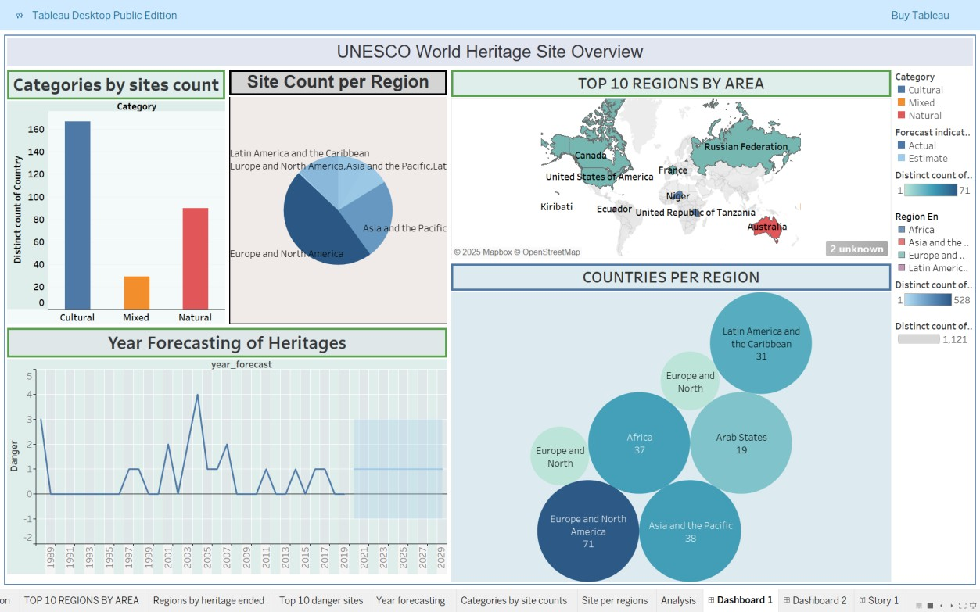

Dashboard – 2: UNESCO DANGER SITE OVERVIEW
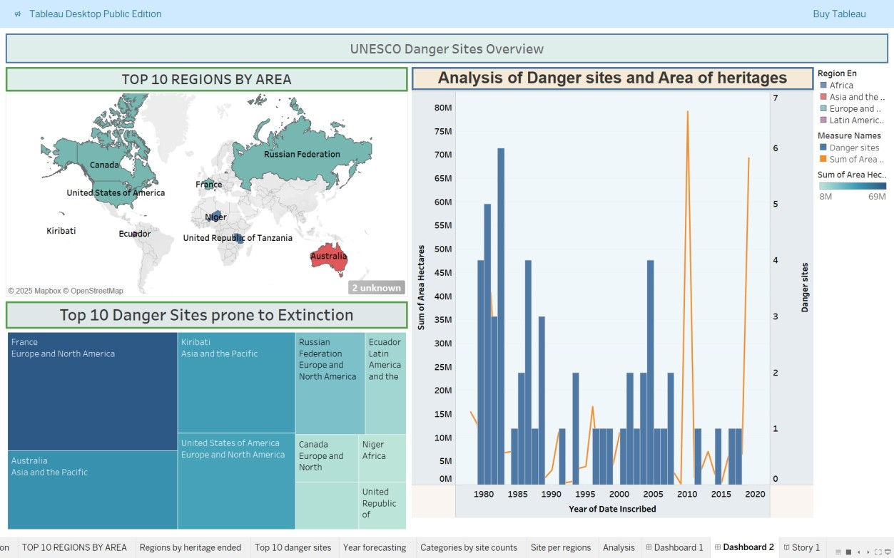

Story: UNESCO WORLD HERITAGE INSIGHTS
